SNP - 02
CLASS 08 - SCIENCE

 | Section A
1 | Read the text carefully and answer the questions: Anuj is studying about safety measures that one should take during lightning and thunderstorm. Hearing thunder is an alert to rush to a safer place. After hearing the last thunder, wait for some time before coming out of the safe place. He also read what should we do and dons. And he also study about the Lighting conductor. 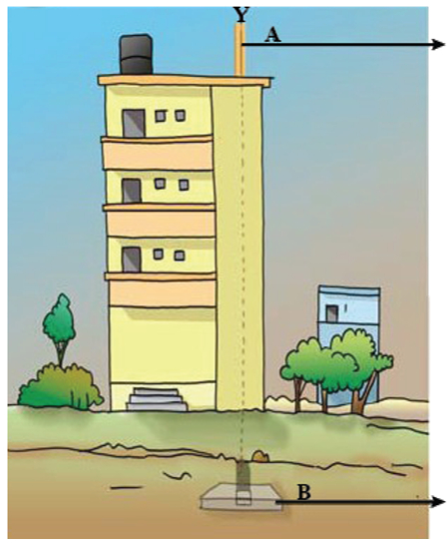  - Identify A in the figure given above  - a) Insulator  - b) Lighting conductor  - c) Copper plate  - d) None of these  - Lightning conductor is used  - a) To protect the buildings  - b) None of these  - c) To destroy the buildings  - d) Both To destroy the buildings and To protect the buildings  - Lightning can strike  - a) Electrical wires  - b) All of these  - c) Telephone cords  - d) Metal pipes  - Part B in the figure given above is ________.  - Bathing should be avoided during thunderstorms to avoid contact with running water. | [5]
2 | Read the text carefully and answer the questions: Two group of students carrying the following activity Step 1 - Inflate two balloons. Hang them in such a way that they do not touch each other. Step 2 - Rub both the balloons with a woollen cloth and release them.   - The two balloon in the above activity will  - a) None of these  - b) Repel each other  - c) No interaction takes place  - d) Attract each other  - Types of charges gained by rubbing objects are  - a) 0  - b) 3  - c) 4  - d) 2  - If same activity is performed by charge refill and charged balloon then what will happen  - a) Attract each other  - b) No interaction take place  - c) None of these  - d) Repel each other  - The current in a circuit which makes a bulb glow, or the current that makes a wire hot, is nothing but a ________ of charge.  - When a charged glass rod is brought near a charged plastic straw rubbed with polythene there is attraction between the two. | [5]
3 | Read the text carefully and answer the questions: Natural phenomena can cause large scale destruction of human life and property. Fortunately, these phenomena can be predicted to some extent. The weather department can warn about a thunderstorm developing in some area. Major earthquakes are much less frequent. They can cause immense damage to buildings, bridges, dams and people. There can be a great loss to life and property.  - The major earthquake occurred in India on 8 October 2005 in  - a) Both Uri and Tangdhar  - b) Tangdhar  - c) None of these  - d) Uri  - Identify A in the figure given below 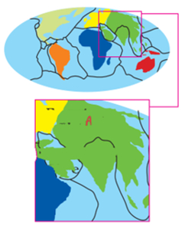  - a) Indian plate  - b) Eurasian plate  - c) None of these  - d) Arabian plate  - A major earthquake occurred in Bhuj district of Gujarat on  - a) 26 January 2001  - b) None of these  - c) 30 February 2002  - d) 15 January 2002  - The power of an earthquake is expressed in terms of a magnitude on a scale called ________.  - In India, the areas most threatened to earthquake are Kashmir, Western and Central Himalayas. | [5]
4 | Read the text carefully and answer the questions: Step 1 - Take an empty jam bottle. Take a piece of cardboard slightly bigger in size than the mouth of the bottle. Step 2 - Pierce a hole in it so that a metal paper clip can be inserted. Step 3 - Cut two strips of aluminium foil about 4 cm $×$ 1 cm each. Hang them on the paper clip as shown. Step 4 - Insert the paper clip in the cardboard lid so that it is perpendicular to it. Step 5 - Charge a refill and touch it with the end of the paper clip.   - The process of transfer of charges from a charged object to the earth is called  - a) Lightning  - b) Electron movement  - c) Oscillation  - d) Earthing  - Earthing is provided in buildings to  - a) None of these  - b) Provide more light  - c) Prevent from sparking  - d) Protect from electrical shocks due to any leakage of electrical current.  - The SI unit of electric charge is  - a) Coulomb  - b) Ampere  - c) Joule  - d) Watt  - The device used to test whether an object is carrying charge or not. The device is known as ________.  - Electrical charge can be transferred from a charged object to another through a metal conductor. | [5]
5 | Read the text carefully and answer the questions: In ancient times, people did not know the true cause of earthquakes. The tremors are caused by the disturbance deep down inside the uppermost layer of the earth called the crust. The outermost layer of the earth is not in one piece. Tremors on the earth can also be caused when a volcano erupts, or a meteor hits the earth, or an underground nuclear explosion is carried out. 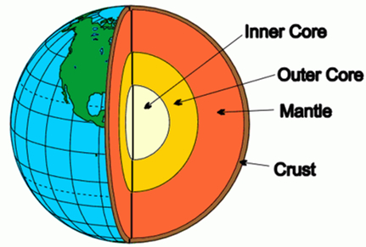  - The shaking and trembling of earth is called  - a) Volcano  - b) Tsunami  - c) Earthquake  - d) None of these  - Earthquake of which magnitude of the following cause the maximum damage?  - a) 8.0  - b) 4.0  - c) 3.0  - d) 5.0  - The magnitude of an earthquake is measured in  - a) Decibel scale  - b) Richter scale  - c) Kelvin scale  - d) Celsius scale  - The outer layer of the earth is ________.  - We can predict an earthquake. | [5]
 | Section B
6 | Which of the following cannot be charged easily by friction?  a) A woollen cloth  b) A plastic scale  c) A copper rod  d) An inflated balloon | [1]
7 | A balloon, when taken near candle, burst because  a) Balloon reduced in size  b) Air inside condense  c) Air inside expands  d) Balloon melts | [1]
8 | Dark funnel shaped cloud reaches to earth from sky are called  a) Lightening  b) Cloud burst  c) Tornado  d) Typhoon | [1]
9 | An object becomes charged when the atoms in the object gain or lose  a) Proton  b) Neutron  c) Positron  d) Electron | [1]
10 | Rearranging charges in uncharged metal object without contact with charged object is called  a) Conduction  b) Insulation  c) Electrical discharge  d) Induction | [1]
11 | Where is the lightning rod attached to protect the building from lightning?  a) On the bottom of building  b) behind the building  c) In the middle of building  d) On the top of building | [1]
12 | Natural disaster can not be predicted as  a) They occurs suddenly  b) They last for short duration  c) They do not provide clue  d) They are rare | [1]
13 | Building can be protected from lightening by using  a) Lightening rod on the levels of building  b) All of these  c) Lightening rod at the top of building  d) Wooden logs at the top of building | [1]
14 | Lightningis seen little earlier than thunder sound because  a) Light require medium for propagation  b) Light moves slower than sound  c) Light travels faster than sound  d) Sound require medium for propagation | [1]
 | Section C
15 | Assertion (A): It is safer to stand under a tall tree during lightning. Reason (R): It will make you the target for lightning.  a) Both A and R are true and R is the correct explanation of A.  b) Both A and R are true but R is not the correct explanation of A.  c) A is true but R is false.  d) A is false but R is true. | [1]
16 | Assertion (A): The whole crust of the earth is in one piece. Reason (R): Richter scale is used to measure the power of an earthquake.  a) Both A and R are true and R is the correct explanation of A.  b) Both A and R are true but R is not the correct explanation of A.  c) A is true but R is false.  d) A is false but R is true. | [1]
17 | Assertion (A): An earthquake is a sudden shaking or frembling of the earth which lasts for very short time. Reason (R): Earthquake caused by a disturbance deep inside the earth crust.  a) Both A and R are true and R is the correct explanation of A.  b) Both A and R are true but R is not the correct explanation of A.  c) A is true but R is false.  d) A is false but R is true. | [1]
18 | Assertion (A): Electrical charge can be transferred from a charged object to another through a metal conductor. Reason (R): Metal is a bad conductor of electricity.  a) Both A and R are true and R is the correct explanation of A.  b) Both A and R are true but R is not the correct explanation of A.  c) A is true but R is false.  d) A is false but R is true. | [1]
19 | Assertion (A): The electrical charges generated by rubbing are static. Reason (R): When charges move, they constitute an electric current.  a) Both A and R are true and R is the correct explanation of A.  b) Both A and R are true but R is not the correct explanation of A.  c) A is true but R is false.  d) A is false but R is true. | [1]
20 | Assertion (A): Lightning is caused by the accumulation of charges in the clouds. Reason (R): In highly seismic areas, the use of mud or timber is better than the heavy construction material.  a) Both A and R are true and R is the correct explanation of A.  b) Both A and R are true but R is not the correct explanation of A.  c) A is true but R is false.  d) A is false but R is true. | [1]
21 | Assertion (A): Lighting strikes could destroy life and property. Reason (R): Lighting conductors can protect buildings.  a) Both A and R are true and R is the correct explanation of A.  b) Both A and R are true but R is not the correct explanation of A.  c) A is true but R is false.  d) A is false but R is true. | [1]
22 | Assertion (A): Lightning conductors are used to protect buildings from lightning. Reason (R): Direct lightning strike is useful.  a) Both A and R are true and R is the correct explanation of A.  b) Both A and R are true but R is not the correct explanation of A.  c) A is true but R is false.  d) A is false but R is true. | [1]
23 | Assertion (A): The innermost part of the earth is called its core. Reason (R): The central region of the earth is called the crust.  a) Both A and R are true and R is the correct explanation of A.  b) Both A and R are true but R is not the correct explanation of A.  c) A is true but R is false.  d) A is false but R is true. | [1]
24 | Assertion (A): The seismic waves are recorded by seismograph instruments. Reason (R): The tremors produced waves on the surface of the earth called waves.  a) Both A and R are true and R is the correct explanation of A.  b) Both A and R are true but R is not the correct explanation of A.  c) A is true but R is false.  d) A is false but R is true. | [1]
 | Section D
25 | State True or False:  - The plates of the outermost layer of the earth are always in continuous motion.  - The nature of charge depends upon the nature of materials.  - Lightning conductor can protect a building from lightning.  - West Bengal is the most threatened by earthquakes.  - The core of earth is made up mostly of iron.  - The magnitudes higher than 3 on Richter scale are considered destructive.  - Lightning conductor cannot protect a building from lightning.  - Insulators get charged by rubbing while held in hand.  - Glass, woollen cloth and hair get negatively charged on rubbing.  - Like charges attract each other.  - Lightning strikes are more frequent in hilly areas.  - Earthquakes can be predicted in advance.  - Skin is not a conductor of electricity.  - The magnitude of an earthquake is measured on the Richter scale.  - Tremors on the earth cannot be caused by the eruption of a volcano.  - A charged glass rod attract a charged plastic straw  - Bathing outdoors should be avoided during a thunderstorm.  - 70% of the Earth’s volume makes up the mantle.  - Earthquakes occur all the time all over the world.  - The process of electric discharge can occur between clouds and the earth. | [20]
 | Section E
26 | Match the items given in Column A with those in Column B suitably: 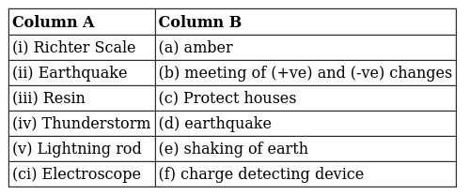 | [2]
27 | Match the following: 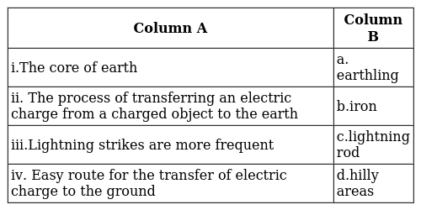 | [2]
28 | Match the following: 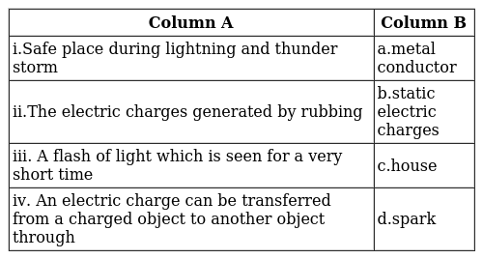 | [2]
29 | Match the following: 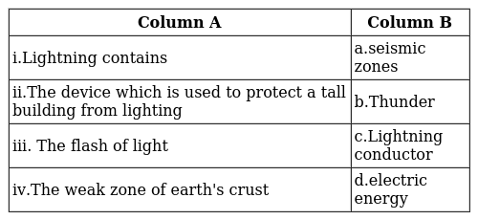 | [2]
30 | Match the following: 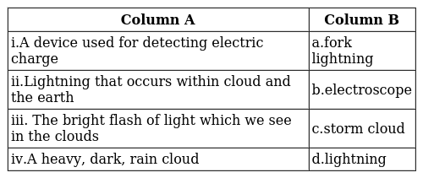 | [2]
31 | Match the following: 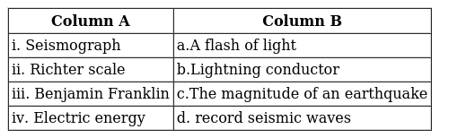 | [2]
 | Section F
32 | Skyscrapers contain ___________ to prevent lightningat the top of building.  a) Lightningconductor  b) Rain gauze  c) Earth wire  d) Insulators | [1]
33 | During lightningactually ________ take place.  a) All of these  b) Electric charging  c) Electric discharge  d) Electric charge accumulation | [1]
34 | Some object can be charged by _________ with other objects.  a) Touching  b) Heating  c) Joining  d) Rubbing | [1]
35 | Lightening is _________ on huge scale.  a) Electric spark  b) Electro - magnetic effect  c) Heating effect  d) Magnetic effect | [1]
36 | Warm air is _________ than cold air.  a) Heavier  b) Same  c) Neither lighter nor heavier  d) Lighter | [1]

